**“Localization and Tracking using radio waves”**

**Final Year Project**

**By**

**Saad Ur Rehman (2016-NUST-BEE 8-178229)**

**Muhammad Gul (2016-NUST-BEE 8-186383)**

**AbdurRehman (2016-NUST-BEE 8-183318)**

**In Partial Fulfillment Of the Requirements for the degree**

**Bachelors of Engineering in Electrical Engineering (BEEE)**

**School of Electrical Engineering and Computer Science**

**National University of Sciences and Technology**

**Islamabad, Pakistan**

**Declaration**

It is hereby declared that this project report titled “Localization and Tracking using radio waves” submitted to the “School of Electrical Engineering and Computer Science”, is a record of an original work done by us under the guidance of Supervisor “Dr. Fahd Ahmad Khan” and that no part has been plagiarized without citations. We have tried to implement the research paper “Partially coherent radar unties range resolution from bandwidth limitations”. Submitted by Saad Ur Rehman (2016-NUST-BEE8-178229), Muhammad Gul (2016-NUST-BEE8-186383) and AbdurRehman (2016-NUST-BEE 8-183318**)**

**Advisor: __________________________**

**( Dr. Fahd Ahmad Khan)**

**Co-Advisor: _________________________**

**( Dr. Wajahat Hussain)**

**DEDICATION**

**To Allah the Almighty**

**&**

**To my Parents and Faculty**

**Acknowledgments**

All gratitude to the almighty ALLAH the gracious, the most beneficent who gave us courage and wisdom to undertake and the grace of Allah, the Almighty, we have been able to accomplish this task. We owe special thanks to our supervisor Dr. Fahd Ahmed Khan, whose comprehensive guidance and thought-provoking ideas helped us in accomplishment of our project. We are thankful to all the faculty members who shared their knowledge and experiences with us especially without technical guidance and help of Dr. Fahd Ahmed Khan that he extended to us whenever we needed help they were available for us. We pay our gratitude towards all the members who helped us in proofreading and editing of the project. Thanks are due to our parents and siblings whose encouragement and motivation remained with us throughout our project. These all people helped us a lot otherwise we would have not been able to complete this task.

**Table of Contents**

Abstract viii

Introduction 9

Important Terminologies 9

Project Objective 11

Research Questions 11

Project Significance 11

Literature Review 12

● Radar Partial Coherence Theory: An Introduction 12

● Adaptable Bandwidth for Harmonic Step-Frequency Radar 13

● Partially coherent radar unties range resolution from bandwidth limitations 14

Methodology 15

Why MatLab? 15

Equipment used for development 15

● **Directional Antenna** 16

Functionality 16

**Transmission signal synthesis** 16

Cross- correlation 17

Testing 18

Graphic User Interface (GUI) 19

Results 22

Single Stationary target 22

Multiple Stationary targets 23

**Processing Two targets individually:** 23

**Processing Two targets combined:** 24

**Single moving target** 24

Discussion 26

Partially coherent radar and existing approaches 26

Conclusion 27

Sweep-time and bandwidth 27

Recommendations 28

Limitations 28

Project Implications 28

References 30

**List of Figures**

Figure 1: Working Diagram of System [2] 9

Figure 2: Graphical User Interface 18

Figure 3: Single Object Detection I 19

Figure 4: Single Object Detection 19

Figure 5: Multiple Object Detection 20

Figure 6: Result I 21

Figure 7: Result II 21

Figure 8: Result III 22

Figure 9: Result IV 23

Figure 10: Result V 24

# 

# Abstract

Localization of an object using radar is an active research field. Researchers are constantly looking for new methods to make radars more efficient and cost effective. Biggest hindrance faced by radars today is the need for large bandwidth. Transmitting a signal in a high band with large bandwidth is very expensive. Large bandwidth is required to distinguish between two closely placed objects in a dense region. This phenomenon called range resolution improves with increase in bandwidth. This project aims to find a solution to eliminate large bandwidth requirements for superior range resolution. Ni- USRP, a software radio peripheral acts as a transducer for signal transmission and reception. The theory tested can be implemented using hardware and the new technology can easily be installed in existing beamform radios. The new technology developed will be free of bandwidth limitation and can be used to distinguish between two closely situated objects. The new technology has vast application in the automotive, security and tracking industry to cope with the ability to differentiate between objects situated in close proximity.

***Chapter 1***

# Introduction

Radio detection and ranging, or “radar” usually operates in the high-frequency part of the radio frequency spectrum. It is used to detect the range, position and velocity of the objects. Radar’s ability to distinguish between two objects in close proximity is called range resolution. This ability is inversely dependent on the bandwidth of the transmitted signal. The term called range accuracy is the certainty with which a single target’s distance is known, also exhibits an inverse relationship with bandwidth [1]. This results in expensive high-bandwidth implementation in applications which require higher range accuracy and range resolution. Automotive and security industries can be considered as prime examples which require a bandwidth of over 1 GHz to obtain a resolution better than 1 meter. Typically, such large bandwidth cannot be achieved without spending a lot of money on expensive hardware implementations first. Even if you possess the ability of transmitting a signal in large band range, there is a possibility that you might cause interference with some other signal.

In this report we demonstrate to you the simulated version of a ranging system possessed with superior range resolution which is not restricted by bandwidth limitation. Research shows that the bandwidth requirement can be minimized by trading it for longer sweep time. Hence, a system was developed impartial of bandwidth limitation at the expense of longer acquisition time. Cross-correlation was calculated of transmitted signal and received signal at some time delay. This cross-correlation was used to determine range resolution and range accuracy.

## 

## Important Terminologies

**Range Resolution:** The ability of the radar system to differentiate between two targets situated in close proximity. It relates inversely with the bandwidth of the transmitted signal.

**Bandwidth:** Range of frequencies within a continuous band i.e subtracting lower frequency from higher frequency.

**Sweep time:** The time taken to complete one sweep of the source and get data over the defined frequency range [2].

**Coherence Length:** The distance of the propagation over which a coherent wave maintains some coherence.

**Cross correlation:** It is the measure of similarity of two signals as a function of the displacement of one relative to another.

**Carrier Frequency:** It is referred to as center frequency in frequency modulated carrier wave.

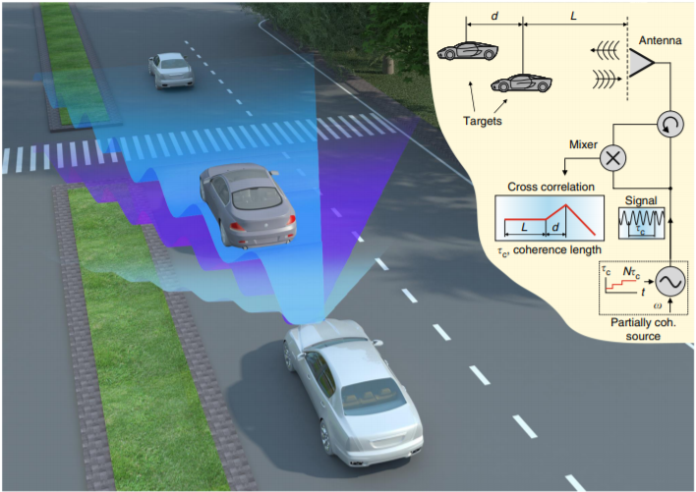

***Figure 1: Working Diagram of System [2]***

## 

## Project Objective

The main objective of this project was to overcome bandwidth limitation when it comes to detecting the range resolution. Limited bandwidth is a major cause of concern in this digital world. At the end of this project we aim to have a simulated system with superior range resolution free of bandwidth limitation. The main objectives are:

* Detecting distance of single target from source
* Detecting distance of multiple targets from source
* Detection of velocity of moving target(s)
* Distance between two closely situated objects

## Research Questions

We hope to answer the following questions at the end of our project:

* What’s the relationship between range resolution and bandwidth?
* How is cross-correlation calculated?
* What’s the relationship between bandwidth and sweep time?
* How does bandwidth affect range accuracy?

## Project Significance

This project is significant because it aims to overcome bandwidth limitation faced by many ranging and detection systems. A high bandwidth is required to be able to detect two targets placed in close proximity. This phenomenon causes hindrance in detecting the right target in a densely populated region. Through our approach we are working towards overcoming the high bandwidth required to differentiate between two objects placed in close proximity to each other.

# 

# *Chapter 2*

# Literature Review

## Radar Partial Coherence Theory: An Introduction

William Blau has placed emphasis on highlighting about the radar partial coherence theory. Radar partial coherence theory is recognized as the one that tends to highlight the structure of a particular clutter or a certain target [3]. Moreover, it also explains the relation of the target with the cross section of radar, its output signal and also with the waveform coding. According to this research article, for a point target, Woodward function is embraced by the clutter ambiguity function. Proceeding ahead, in this research paper author has mentioned that targets as well as the radar signals are equated in terms of the functions of mutual coherence because of the non-linear effects generated by the partial coherence. Basic quantities that define the radar output include target mutual coherence function and also the radar mutual coherence function. The radar mutual coherence function in actual is equated in terms of “radar waveform” while radar mutual coherence function tends to depend on the physical environment and also on the target properties. As per this research article, reflecting figure’s coherent portions that are partial have been made accountable in this theory along with the component of the random noise. This research paper has presented a theory of radar partial coherence. Intrinsic radar’s mutual coherence functions were explained in terms of the cross-correlation functions of the intrinsic radar. Moreover, the point ambiguity function was also defined in the similar way [3]. The theory overall adds value into the radar target’s description. Moreover, it has also been explained that by including amplitude-phase into the clutter allows the identification of target in relation to the mutual coherence functions. However, at the end the author has mentioned that waveform coding can be implemented to augment as well as to reduce the radar cross-section of the objects selected-the ones who permit the resolution as well as the target discrimination.

## Adaptable Bandwidth for Harmonic Step-Frequency Radar

Martone et al., (2015) has placed emphasis on describing the spectrum sensing technique. It is the technique that increases the working of a harmonic step-frequency radar. It augments the working in the existence of harmful radio frequency interference (RFI) [4]. Within a limited interested bandwidth, this method is used to monitor as well as assess the “RF spectrum for the high signal-to-interference-plus-noise ratio (SINR)’s sub-bands.” In this research paper in order to minimize the cell size’s range resolution an appropriate sib-band for the harmonic radar has been selected. Moreover, it has also been selected to maximize the high signal-to-interference-plus-noise ratio (SINR). This technique has been also tested practically. A practical project has been built, where a high power radio frequency interference (RFI) has been injected into a harmonic step-frequency radar. This decreases the performance of a radar immensely. Results of this research paper depict that the SS-MO method tends to augment the signal-to-interference-plus-noise ratio (SINR) over the 25 decibels for the wideband inference as well as for the deterministic narrowband [4]. Moreover, it also enhances the poor peak-to-side-lobe ratio (PSLR) by approximately 15 decibels. The technique is quite significant, for it decreases the rate of wrong alarms and also increases the performance of detection. SS-MO technique enables the detection of reactions from non-linear targets by the harmonic radar. At the end of the research paper, the author has mentioned certain disadvantages of using SS-MO technique at the range resolution for the harmonic step frequency radar. Firstly, the size of the range resolution cell increases that could further lead to the radar’s inability. Radar becomes unable to utilize its features that are used for the classification of targets. Moreover, it also becomes unable to separate the targets that are quite close to one another.

## Partially coherent radar unties range resolution from bandwidth limitations

Rony, Vitali, Dmitry and Pavel in the research paper entitled as, “Partially coherent radar unties range resolution from bandwidth limitations” has talked about the range resolution and the bandwidth limitations [2]. Range resolution in general refers to the ability that tends to discriminate between the two bodies or objects that are close that are placed quite close to each other. It is inversely related to that of the bandwidth of the radar. Bandwidth in actual means the existence of different frequencies in a particular band. In this research article, a specific type of ranging system has been used. This ranging system has superior range resolution. This range resolution is superior because it is exclusive of all the bandwidth limitations. Partially coherent radar shows betterment in terms of resolving targets after widening over the transmitted signal’s coherence length. It shows better results in comparison to the standard coherent radars. In the current research article, a theoretical framework has been devised in order to depict that further improvement can occur in the resolution. It in actual shows a trade-off between the sweep time and the bandwidth. Authors of this paper highlight that this technique could be further used in order to solve the issues that require accuracy as well as high range resolution but because of limited bandwidth they have become a serious concern. It can be used in case of the optical imaging, in the genre of astronomy and also for the industry of the autonomous cars. This research paper in actual has used the electromagnetic radiation’s statistical properties to overcome the relation existing between the bandwidth and the range resolution of the signals transmitted. A new form of the electromagnetic source that had controlled coherence length was applied. It further demonstrated a ranging system constituting a super resolution. The system could be practically implemented in order to promote smoothness into the operations of various industries like the aerospace industry.

# 

# *Chapter 3*

# Methodology

After doing some research we found that the biggest hindrance in developing efficient ranging and detection systems was the availability of bandwidth. Range resolution and bandwidth have an intrinsic relationship which demands G (IEEE) band which can incur heavy costs to be able to separate several distant targets that are in close proximity of one another. We aimed at developing a range and detection system free of such limitations. After doing the respective literature review we realized that a system theoretically free of bandwidth limitation could be developed. In order to develop such a system, it was crucial to choose the right software to develop it.

## Why MatLab?

We had the option to develop and test the new system using softwares like GNUradio, LabView and MatLab. GNUradio, a software developed by toolkit, has signal processing blocks which can be used to implement software-defined radios and signal-processing systems. This was naturally our first choice for development, however after spending significant time developing on this software we realized that it does not provide the kind of flexibility matlab would provide [5]. We shifted to MatLab owing to the computational power and flexibility it provides. It was comparatively easier to synthesize the transmission signal with varying coherence length. Due to high frequency of transmission, significantly much higher sampling frequency was required to satisfy the nyquist criteria which could only be sampled and stored at a much higher rate in matlab only.

## 

## Equipment used for development

* **NI-USRP**

Universal software radio peripheral is a device developed and manufactured by ettus research, whose parent company is national instruments. USRP, a software defined radio equipment which can be connected to a host computer to transmit and receive data. USRP is a generally inexpensive platform for software radio [6].

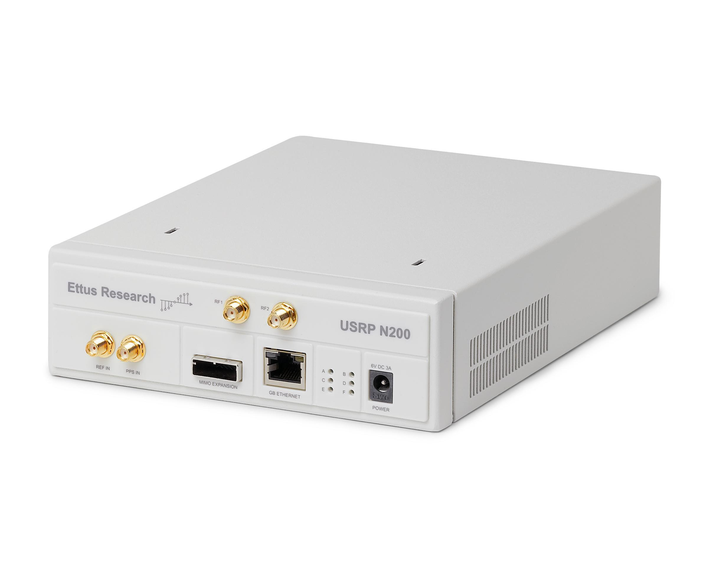

### **Directional Antenna**

A directional antenna is designed to work with greater efficiency or power in some specific direction as compared to all the directions. This is done to reduce interference from unwanted sources to improve performance.

## 

## *Chapter 4*

## Functionality

Rf technology permits vast control over coherence. To be able to implement this partially coherent source, the carrier frequency wave can be changed in the range [0, 2𝜋].

### **Transmission signal synthesis**

Transmission signal proposed is composed of “M” coherence lengths, where each coherence length is made up of “N” phase jumps. We synthesize a transmission signal with following time domain specifications:

* M=coherence lengths=300
* N=phase jumps in each coherence lengths=15
* Fc=Center Frequency=6GHz
* Fs=sampling frequency=(N+1)*Fc=96GS/s
* No.of cycles per phase jump(1st window)=2
* No.of cycles added to each phase jump after each successive coherence length=1
* Total phase jumps=2*pi/((N+1)*(M+1))

Radar signal is given by; S(t)= cos(wt + Φ(t)).

Where, w= carrier frequency

n= 1,....,N+1  
m= 1,....,M+1

## Cross- correlation

The transmitted signal is constituted of a continuous waveform. The phase of the waveform switches at random every Tm seconds, this results in a coherent window of length C.Tm. When the transmitted waveform hits the target within the coherent window, a signal will be reflected which will be obtained at some time delay . Reflected signal can be divided into two parts—the first part of duration span (Tm - ), which is in correlation with the still transmitting signal that is in the same phase, the second part of duration is uncorrelated with the transmitting signal. The cross-correlation Cm, for coherence time interval Tm, is measured by changing the phase N times and averaging the product of the reflected and transmitting signal. If the target is not within the coherence length the cross-correlation averages to 0.

Cm=

## Testing

The code developed on matlab needed to be tested for any changes and improvements before moving on to the hardware implementation part. NI- USRP, a software defined radio peripheral developed by etus technology is a pretty good tool for signal transmission and reception. After attaching directional antennas to the usrp, matlab code was burnt onto the fpga in usrp. The directional antenna is an antenna which is designed to radiate and receive greater power in some specific direction. The signal is transmitted through this antenna, and if an object is detected within the coherence window a reflected signal is received. Cross-correlation is calculated to determine range resolution and range accuracy.

# Graphic User Interface (GUI)

A graphical user interface was created to help ease the users to use the new technology. The user interface designed was kept extremely simple to allow the user to easily observe the object’s distance. User interface comes with a graphical interface that shows the object’s position. Breakpoint denotes the position of the target.

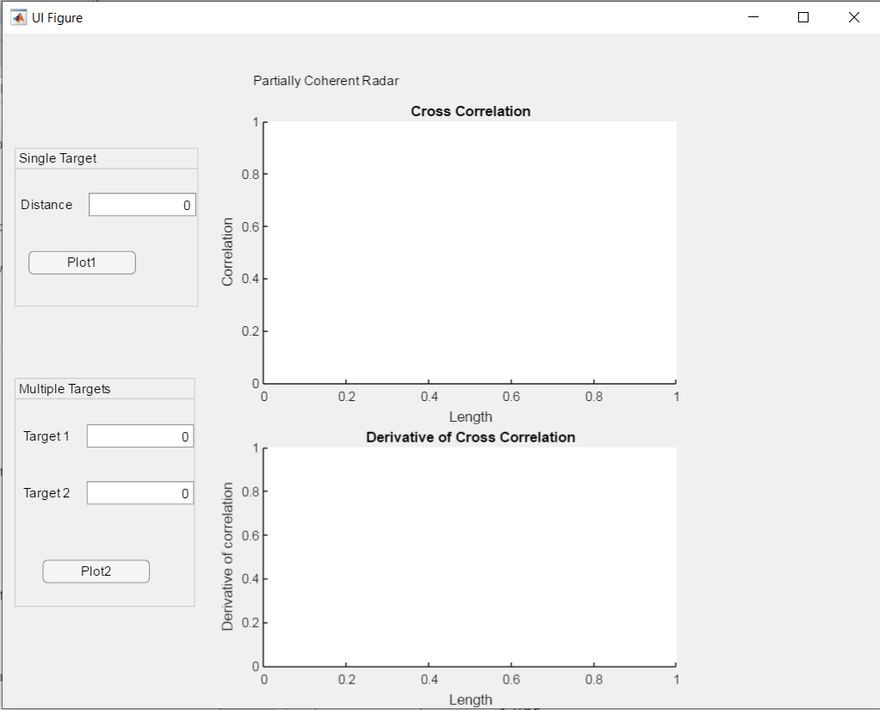

***Figure 2: Graphical User Interface***

* An object was assumed at a distance of 50m, resultantly a breakpoint can be observed at distance= 50m. Breakpoint shows the object’s distance.

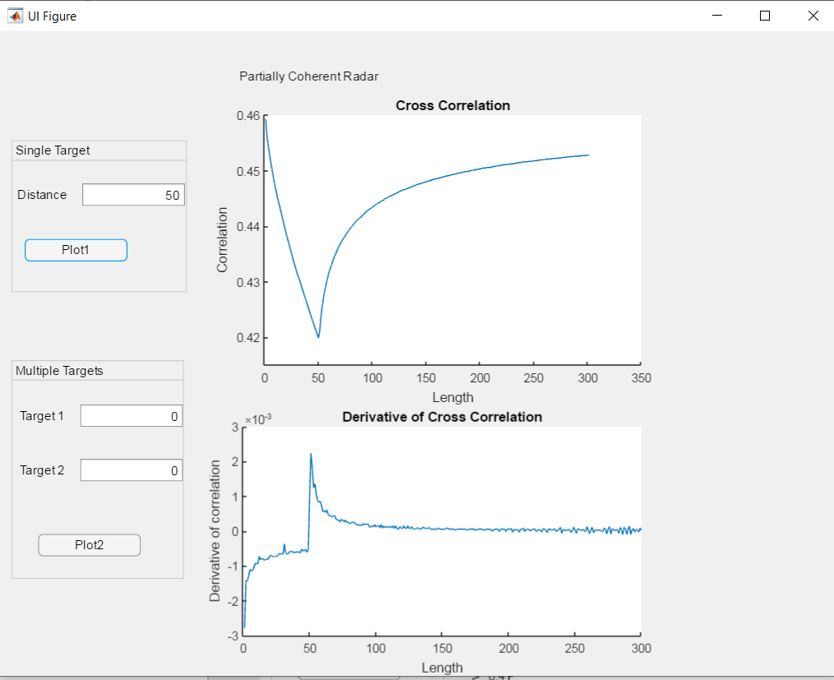

***Figure 3: Single Object Detection I***

* An object was assumed at a distance of 200m, resultantly a breakpoint can be observed at distance= 200m.

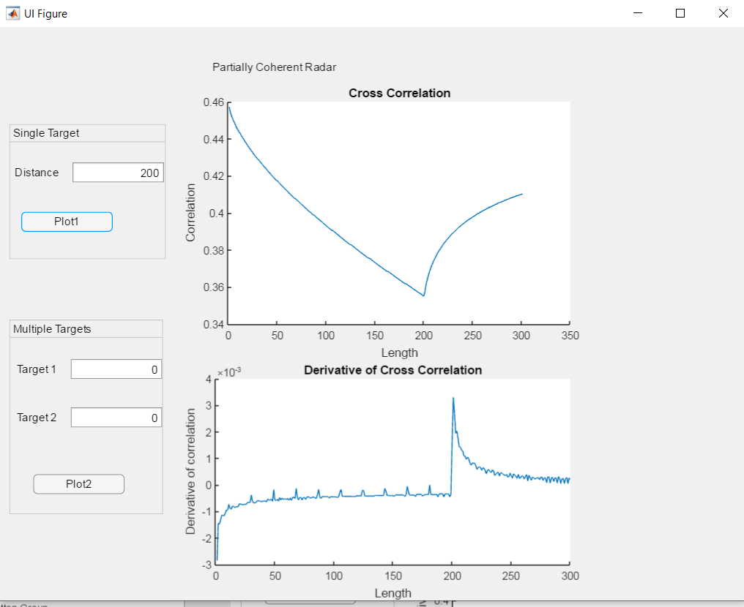

***Figure 4: Single Object Detection***

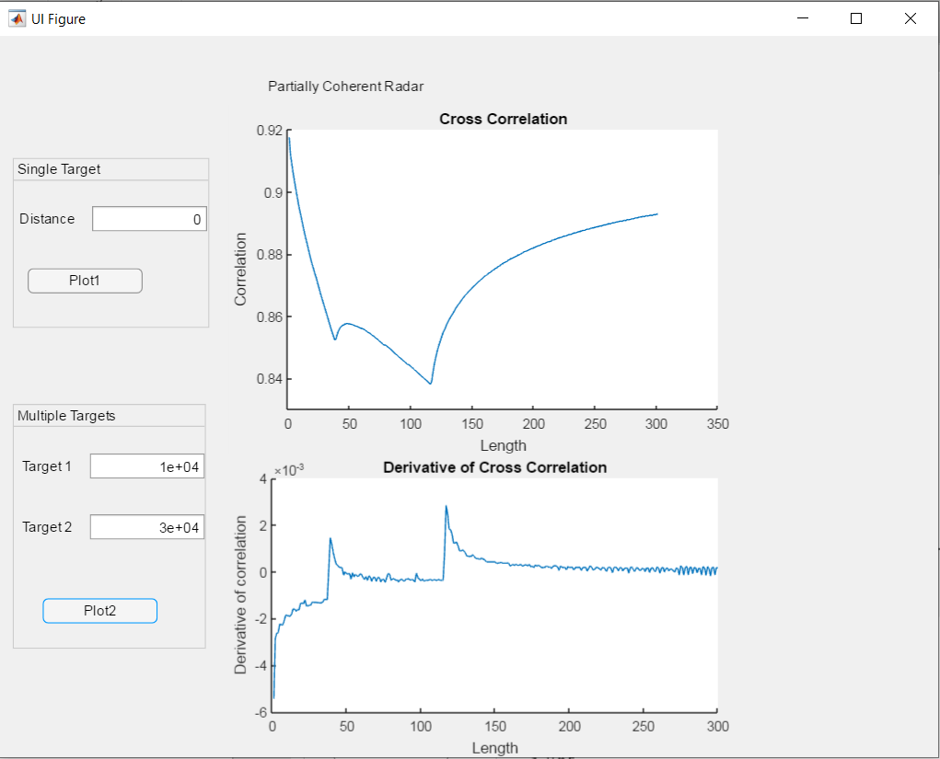

***Figure 5: Multiple Object Detection***

# 

# *Chapter 5*

# Results

## Single Stationary target

A single target object with delay equal to 250th coherence length was assumed. Correspondingly we get a breakpoint at 250, when cross correlation is displayed as a function of coherence length (lm).

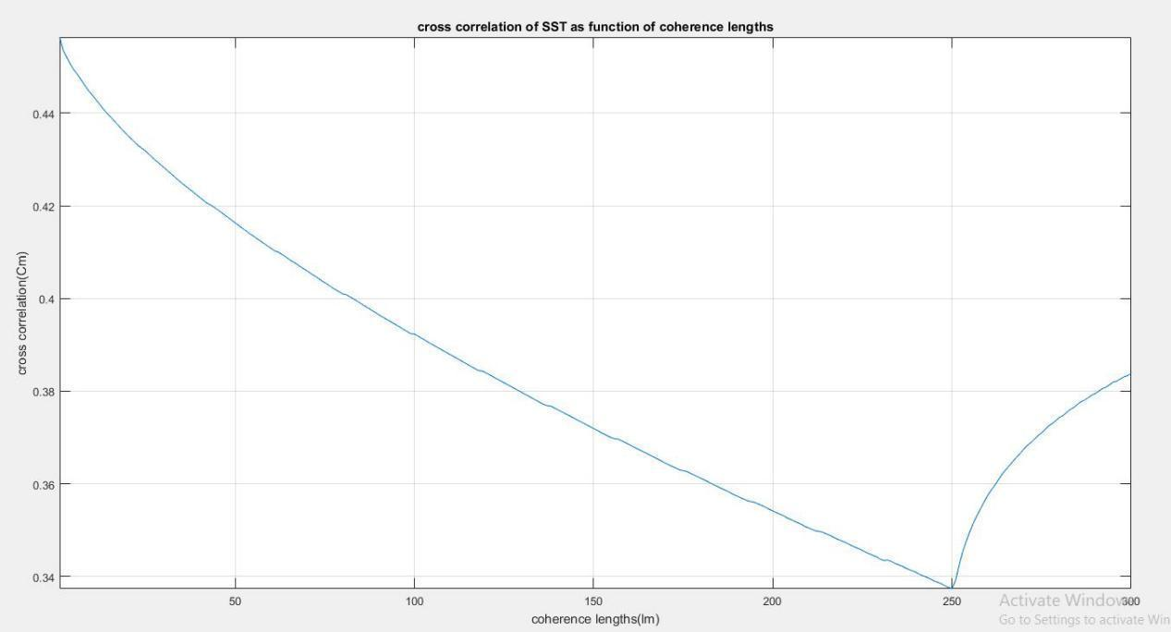

***Figure 6: Result I***

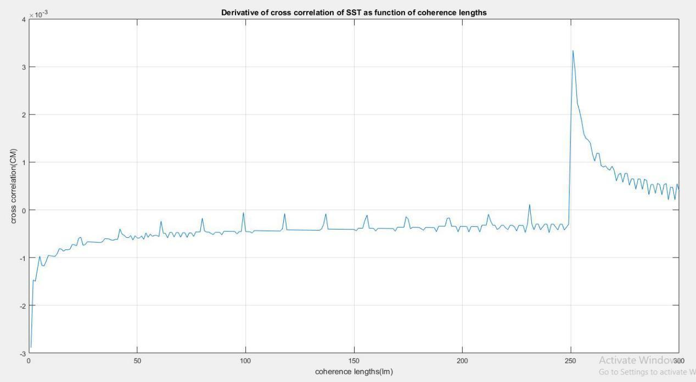

***Figure 7: Result II***

## Multiple Stationary targets

Two stationary targets with delays equal to 10000 samples and 30000 samples corresponding to 41st and 120th coherence length respectively were assumed. Consequently we get two breakpoints and 41 and 120 coherence points.

### **Processing Two targets individually:**

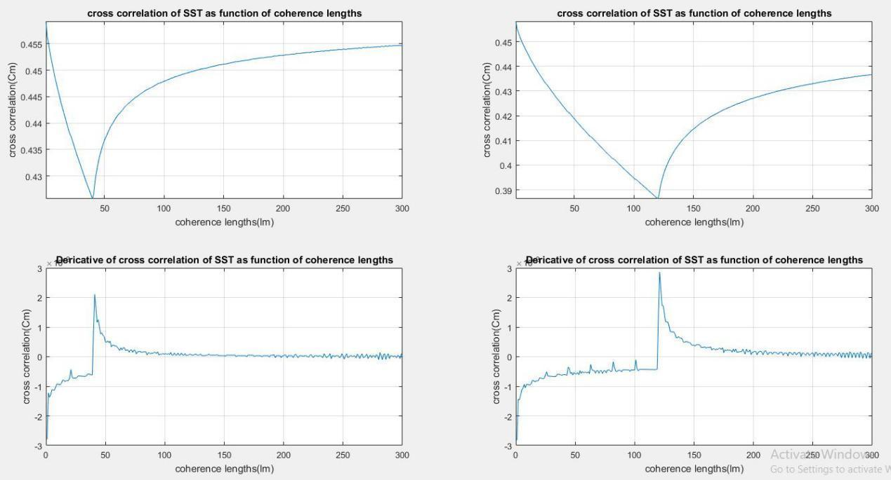

***Figure 8: Result III***

* It can be observed on the derivative curve that the cross-correlation approaches zero after detection of both targets.

### **Processing Two targets combined:**

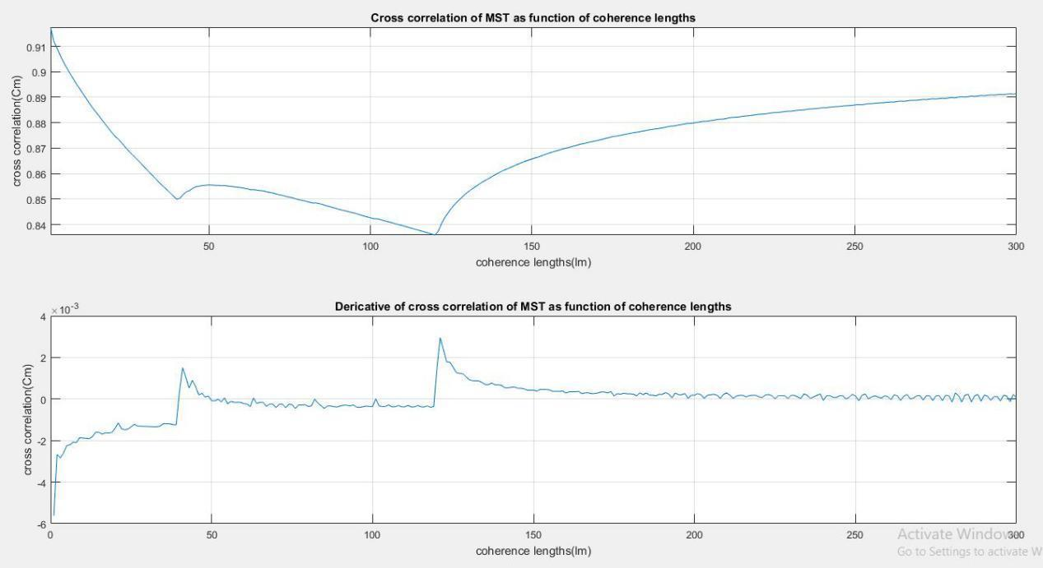

***Figure 9: Result IV***

### 

### **Single moving target**

A single target is assumed to have two different accelerations, one acceleration double of another.

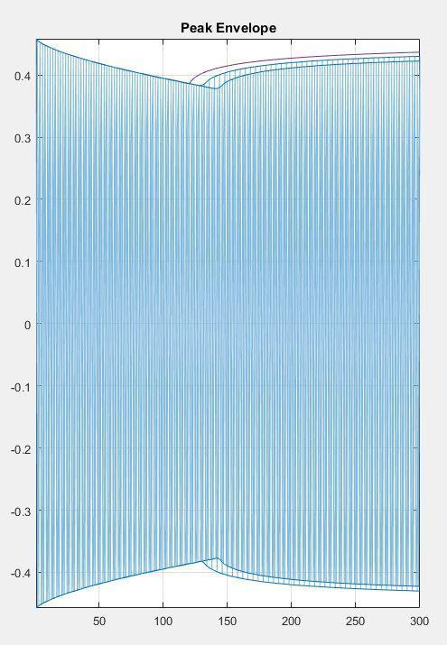

***Figure 10: Result V***

# *Chapter 6*

# Discussion

Most modern radars can be divided into two categories- continuous wave radars which transmit signal continuously and pulsed signal radars that transmit for relatively short periods. However, both these techniques despite major developments carry limitations and trade-offs. Smart algorithms are required to prevent the detection of ghost targets. Pulsed radars usually face “blindness” problems when detecting a target in short range, to avoid this problem frequency modulated carrier wave radar is used, however FMCW radars come with expensive high band requirements and bandwidth limitations for targets close together.

The new partially coherent radar approach is virtually free of bandwidth limitation whether detecting a target in short range or long range. Due to the random nature of electromagnetic radiation, this solution has some distinct pros over conventional radars. New system has comparatively higher immunity to noise and low interception probability which are crucial for military and urban applications. However it may have high insertion loss and demands high-precision controllable delay lines, which are expensive and hard to implement at mm waves. The new approach can be used in sub 1GHz implementations. However, fast moving targets can affect the performance of this new system and may require smarter algorithms for that approach.

# *Chapter 7*

# Conclusion

It is of critical importance to choose the right carrier frequency to avoid zeros in cross-correlation. This requires an additional sweep over the carrier frequency to ensure detection at any range. This additional sweep bandwidth, Δf= , is between 5 and 7.5 MHz for targets 15–10 m away from the radar. It can be shown experimentally that the location of breakpoint on cross-correlation is not affected by choice of carrier frequency, only slope differs.

## Sweep-time and bandwidth

For M coherence sweep points and N pulses that begin at T0, and scan for a coherence time, t, Sweep-time is given by; Tsw=

A good precision of the location of the target requires a higher value of N and M, which results in prolonging the sweep time. Maximum transmitted signal bandwidth depends entirely on starting coherence time i.e T0. Hence,

BWmax=

This lets us rewrite sweep time equation as;

BWmax=

Which shows a clear inverse relationship between maximum transmitted bandwidth and sweep-time. Hence, bandwidth of the transmitted signal can be minimized by increasing the sweep time.

## Recommendations

I would suggest anyone who wants to pursue this project in future to start software/simulation development on matlab. MatLab is a very powerful tool with unmatched computational power and can sample and store data at much faster rate than any other tool. This is important because of high sampling frequency used. Data sampled needs to stored ata afaster rate which can only be achieved throught matlab. NI- USRP used for testing needs to be interfaced with a host computer. I would recommend the developer to use cat5 ethernet cable for seamless connection and quick youtube search will teach you how to interface USRP with your computer.

Furthermore, I would like to recommend the developer to carry out the tests in a controlled environment with minimum personnel to reduce outside interference. This will give you more accurate results and help improve the algorithm. Increasing the coherence length of signal will increase the range of the system and increasing the phase jumps will result in a better cross-correlation function.

## Limitations

Our project could not be implemented on hardware due to the global pandemic of CoVid-19. Lab facility on campus which contained the hardware and equipment for design and implementation of the proposed system needed to be used. Furthermore, some IC’s and hardware equipment needed to be shipped from outside Pakistan for realization of the project. We could not go forward with the original plan of design and implementation of our project owing to the unforeseen special circumstances. Therefore, scope of the project had to be re-evaluated and new objectives were set. This project could greatly be improved if a computer equipped with gpu is used. GPU’s offer fast processing and storage speed which can prove to be of great assistance when dealing with high-frequency signals.

## 

## 

## *Chapter 8*

## Project Implications

Vastly accepted relationship between the bandwidth of the transmitted signal and range resolution is removed by using the statistical properties of electromagnetic radiation. A new type of electromagnetic source with variable coherence length was designed and used, which demonstrates a radar equipped with superior range resolution. The new system could be harnessed to make more bandwidth efficient, low power, and physically compact systems for range detection purposes. This technology could be used with existing scanning systems hence proving to be cost efficient. Many industries like self driving cars, airborne radar systems in drones, aerospace imaging along with some other fields of science and practical applications can use it to vastly enhance their ability of target detection and be able to separate objects closely situated in dense frequency spectrum areas.

# 

# References

|  |  |
| --- | --- |
| [1] | M. I. Skolnik, RADAR systems, McGraw-Hill, New York, 2001. |
| [2] | R. Komissarov, V. Kozlov, D. Filonov and P. Ginzburg, “Partially coherent radar unties range resolution from bandwidth limitations,” *Nature Communications,* vol. 10, no. 1, pp. 1-9. https://www.ncbi.nlm.nih.gov/pubmed/30926800, 2019. |
| [3] | W. Blau, “Radar partial coherence theory: An introduction,” *IEEE Transactions on Aerospace and Electronic Systems,* vol. 2, no. 5, pp. 536-543. https://ieeexplore.ieee.org/document/4501929?arnumber=4501929, 1966. |
| [4] | A. F. Martone, K. A. Gallagher, K. D. Sherbondy, K. I. Ranney, T. V. Dogaru, G. J. Mazzaro, A. F. Martone, K. A. Gallagher, K. D. Sherbondy, K. I. Ranney, T. V. Dogaru, G. J. Mazzaro and R. M. Narayanan, “Adaptable bandwidth for harmonic step-frequency radar,” *International Journal of Antennas and Propagation,* vol. 2015, pp. 6-21. https://www.hindawi.com/journals/ijap/2015/808093/, 2015. |
| [5] | MathWorks, “MATLAB,” MathWorks, 2020. [Online]. Available: https://iwww.mathworks.com/products/matlab.html?s_tid=hp_products_matlab. [Accessed 2 March 2020]. |
| [6] | A. Qureshi, “Interference diagnosis in wireless systems by using NI USRP,” *International Journal of Simulation: Systems, Science and Technology,* vol. 16, no. 6, pp. 1-10. https://gala.gre.ac.uk/14662/, 2015. |